This’ll be the first in a series of visualizations on ‘Data Trends’

Let’s start with something simple – stats about Video-game sales. This data was compiled by [vgchartz.com](http://www.vgchartz.com/), a website that focuses on sales trends within the gaming industry.

Much like how Hollywood movies have an ‘upward trend’ in the #1 box office sales each year, I expected the same to be true for videogames. I anticipated an upward trend in the # of sales of newer games, with the top-selling games constantly breaking sales records each year.

“Best-seller” of the year:

The following shows the sales of the ‘best-selling’ videogame each year.

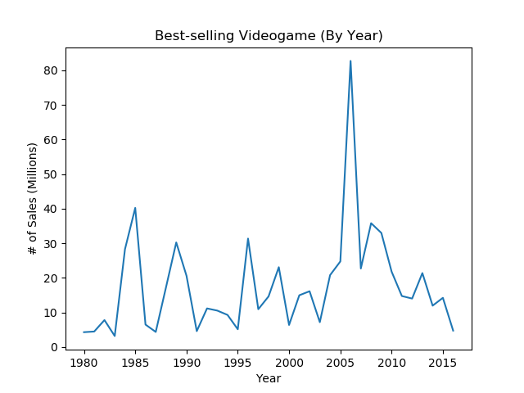

This defied my initial expectations. We see peaks and valleys between the yearly best-sellers. The highest record was around 40 million being set in 1985, and then the next highest was in 2006.

Let’s take a second to talk about the top 7 selling videogames of all time:

# 1: Wii-Sports (2006)

#2: Super Mario Bros. (1985)

#3: Mario Karts Wii (2008)

#4: Wii Sports Resort (2009)

#5: Pokemon (1996)

#6: Tetris (1989)

#7: New Super Mario Bros. (2006)

So what’s similar between all of these games? Aside from being produced by Nintendo (who also hold the record for 22 of the top 25 best-sellers of all time).

I did some googling on these titles, and all 7 games all had ‘bundle’ deals, where you could purchase them as part of a bundle with your game console- essentially giving you a free videogame with a purchase of the device to play videogames on.

Successful games would already be strong consideration to be bundled with the consoles, but these package deals may have contributed to making these games all-time best-sellers.

Even with the data in front of us, it’s hard to imagine Wii Sports selling 82.83 million copies…That’s more than twice the population of Canada (36.29 million in 2016).

Average sales per year:

Shocked that best-selling game records aren’t constantly being beaten, I looked to other statistics. If the best-selling video-game isn’t breaking records each year, I considered that perhaps the average game was selling more copies.

Once again, I am completely wrong.

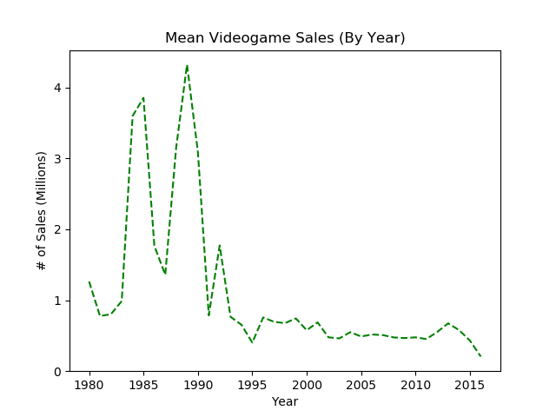

We clearly see a ‘golden age’ of game sales, starting in the mid-80’s and ending in the early 90’s. Things seem to flatten out after that, but sales are nowhere near the monster they are before.

(Bear in mind this is only the top ~16600 games sold- with the bottom of the list only getting around 10k sales globally. Even if the effects on overall averages are only slight, I’m sure there’s a chance that the “bottom of the barrel” sellers who never even made the list have a chance of skewing averages lower. )

This prompts even more questions. I anecdotally hear about how the game industry is growing, and yet these numbers don’t reflect that.

Number of games made:

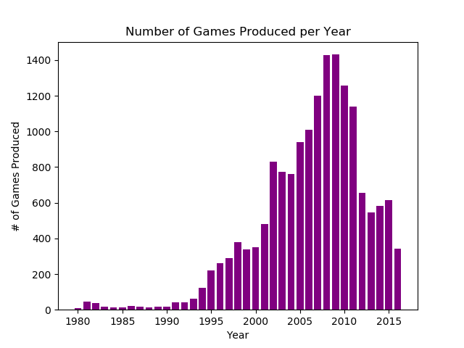

Finally, something that rises, rather than falls!

While numbers seem to be on the decline from the mid-2000’s forward, the number of games being produced are still far higher than they were in the ‘early days’. It’s quite possible that the number of games on the market now is part of the reason why the average game sold fewer copies.

So, more games are being made, but are people buying them?

From the looks of it, yes. The total amount of games SOLD per year is also increasing:

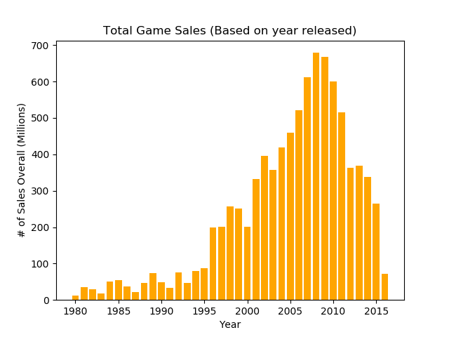

Ancedotes about the gaming industry growing are not unfounded. It’s just that rather than a couple of games dominating in sales, there’s a more diverse marketplace from which to choose from.

The ‘average’ game may be making less revenue past the mid-90’s, but with more options for games available, it’s not due to dwindling interest. There’s simply more competition, and more diversity in what gamers can buy.

As they say, variety is the spice of life. When more games are available, more games are being bought.

Outliers , oddities, and points of note:

This data was scraped during 2017, likely during the beginning of the year. Doing a cursory search for many of the ‘triple-A’ titles, they are missing from the data. As a result, this is assumed to be an accurate of account of sales up until early 2017, but not far after. I choose to remove 2017 data because 2017 isn’t over yet, and many of the games that have come out this year are missing.

Games that were sold cross-platform were evaluated by their sales for each individual platform. So, say, Grand Theft Auto V would be evaluated by its PS4 sales, it’s XBOX sales and it’s PC sales separately.

It’s also important to note that these dates mark the year the game debuted. It may not necessarily be the year the game made the most sales. As a result, it’s important to consider that the production run of a single videogame is going to play a major factor in its global scales.

As a result, I would argue the data is ‘incomplete’ on any game that still hasn’t finished its production run. They still have potential to climb significantly in sales. Especially for games from 2016, which I suspect are still on the shelves.

Sources: Box office grosses: <http://www.boxofficemojo.com/alltime/world/>

To compare to videogames, here’s the trend for Hollywood film sales. (Note that this is in thousands of millions, while best-selling videogames are only 10’s of millions)

